Object Oriented Programming
Lab

Spring-2024

LAB 08


FAST National University of
Computer and Emerging Sciences

Learning Outcomes

In this lab you are expected to learn the following:

● Operator Overloading
Operator Overloading:

C++ allows you to specify more than one definition for an operator in the same scope, which is called operator overloading. Overloaded operators are functions with special names: the keyword "operator" followed by the symbol for the operator being defined.

Syntax for C++ Operator Overloading:

To overload an operator, we use a special operator function. We define the function inside the class or structure whose objects/variables we want the overloaded operator to work with.

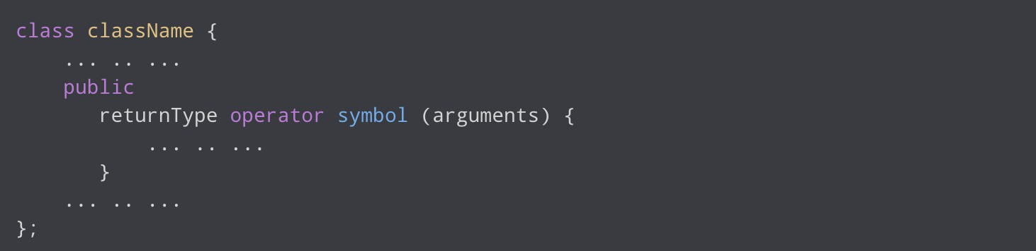

Here,

● returnType is the return type of the function.
● operator is a keyword.
● symbol is the operator we want to overload. Like: +, <, -, ++, etc.
● arguments is the arguments passed to the function.

Stream Insertion and Extraction Operator Overloading

In C++, stream insertion operator “<<” is used for output and extraction operator “>>” is used for input.

We must know the following things before we start overloading these operators:

1. cout is an object of ostream class and cin is an object of istream class
2. These operators must be overloaded as global functions. And if we want to allow them to access private data members of the class, we must make them a friend.
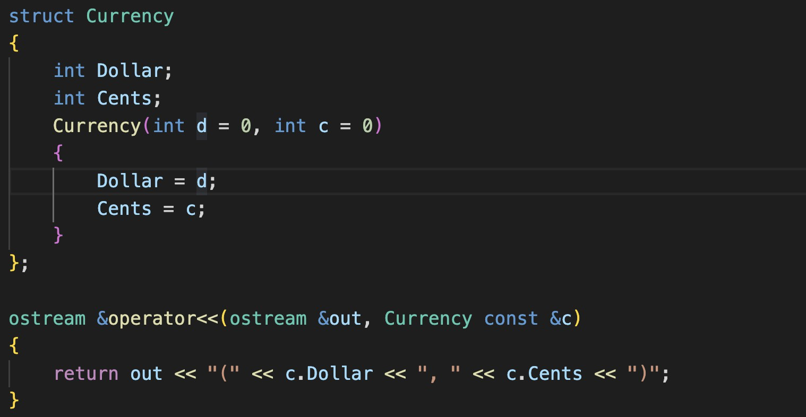
Lab Tasks

Submission Instructions:

1. Create a single cpp file containing all the functions of the problems and main function.
2. Save the cpp file with the task number
e.g. Q1.cpp
3. Now create a new folder with name ROLLNO_SEC_LAB01 e.g. i22XXXX_A_LAB10
4. You need to display your roll no and name before the output of each question.
5. Move all of your .cpp files (without the main function i.e., comment out the main function) to this newly created directory and compress it into a .zip file.
6. Now you have to submit this zipped file on Google Classroom.
7. If you don’t follow the above-mentioned submission instruction, you will be marked zero.
8. Plagiarism in the Lab Task will result in zero marks in the whole category.

Q1. Create a class Money that represents a money value (combination of dollars and cents). The class has the following member functions.
1. Money() // Default Constructor

Initializes dollars and cents to zero

2. Money(int dollar, int cents) // Parameterized Constructor

Update dollar and cents accordingly

Overload the following operators:

3. Money operator+(const Money &obj)

Define an operator + that overloads the standard + math operator and allows one Money object to be added to another.

4. Money operator-(const Money &obj)

Define an operator - that overloads the standard - math operator and allows one Money object to be added to another.

5. const Money operator=(const Money &obj)

Define an operator = that overloads the standard = operator and assigns one Money object to be added to another.
6. Money& operator++ ()

Overload pre increment operator.

7. Money operator++ (int x)

Overload post increment operator.

8. Money& operator-- ()

Overload pre decrement operator.

9. Money operator-- (int x)

Overload post decrement operator.

10. bool operator!= (const Money& right)

Overload not equal operator that checks whether the right object is equal to the current object or not.
Example:
1. M1: 12 dollars 95 cents using parameterized constructor
2. M2: 3 dollars 80 cents using input operator (istream)
3. Perform all the operations as shown below
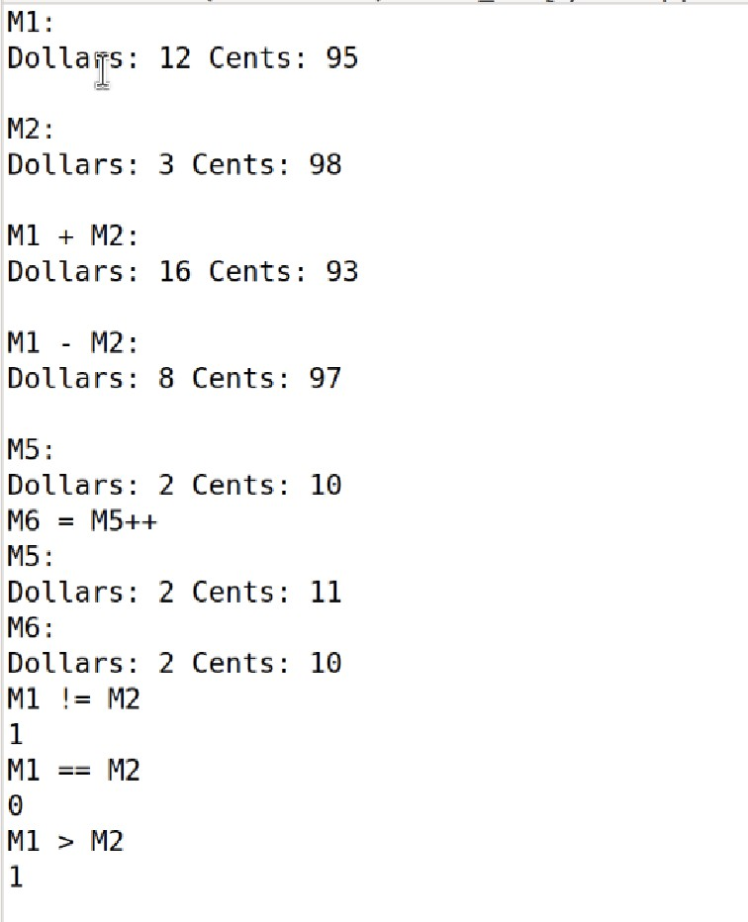

Q2. Implementation of Quadratic Polynomial Class:

Write a class Polynomial. This class has three private data members:

a. int that holds the coefficient of X^2 b. int that holds the coefficient of X
c. A double that holds the coefficient of X^0 (Constant term) The class has the following member functions.
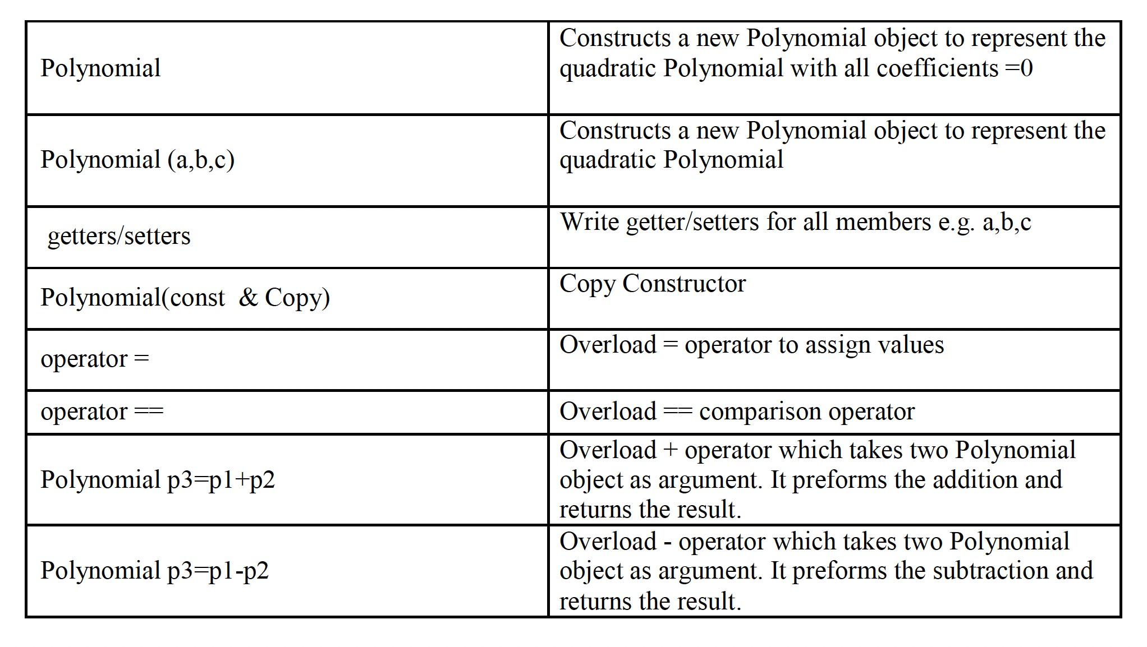

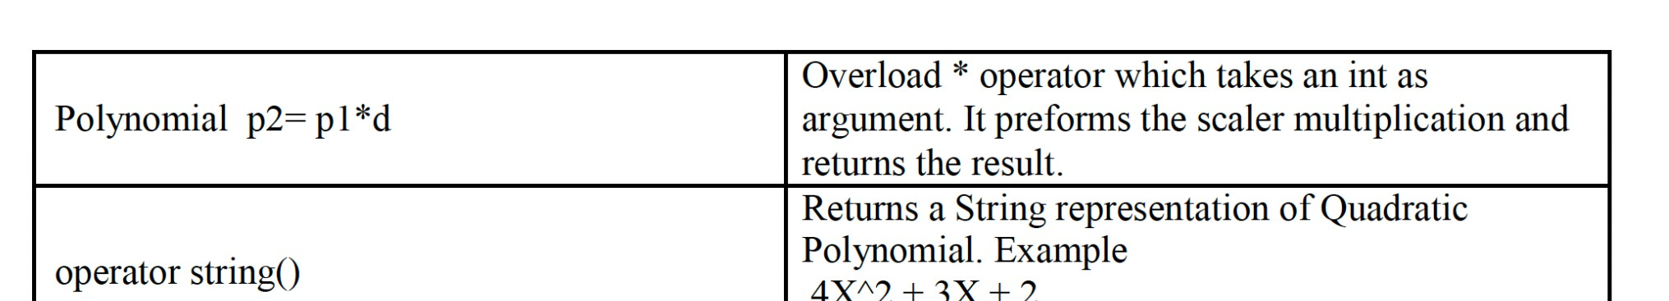

Example:

4. P1: 2x^2 +x -1, P2: 5x^2 -7x +3
5. Perform all the operations as shown below

